МИНИСТЕРСТВО ОБРАЗОВАНИЯ И НАУКИ

РОССИЙСКОЙ ФЕДЕРАЦИИ

ФЕДЕРАЛЬНОЕ ГОСУДАРСТВЕННОЕ АВТОНОМНОЕ

ОБРАЗОВАТЕЛЬНОЕ УЧРЕЖДЕНИЕ ВЫСШЕГО ОБРАЗОВАНИЯ

«САМАРСКИЙ НАЦИОНАЛЬНЫЙ ИССЛЕДОВАТЕЛЬСКИЙ

УНИВЕРСИТЕТ ИМЕНИ АКАДЕМИКА С.П. КОРОЛЕВА»

Кафедра геоинформатики и информационной безопасности

ЛАБОРАТОРНАЯ РАБОТА №1

**«VM and RAID, Minicube»**

Выполнил:

студент группы 6412

Шафранюк Р.О.

Проверил:

Авдеев Е.В.

Самара 2023

TASKS

1. Create virtual machine with debian/ubuntu/centos or download

preinstalled image (https://www.osboxes.org/). It should be withoug GUI.

2. Set hostname = your surname.

3. Add simple raid1 to virtual machine: \*nix os system on 1-st hdd, 2d

and 3d hdds are in raid1. 1 (with star). Only two hdds. Os system on

raid1, based on this two hdd.

4. How to test raid1. Create file on raid1 file system. Turn off vm and

remove one of the hhds from vm. Turn on vm. File should be

accessible.

5. Add new hdd and sync it to raid1.

6. Install and run local Kubernetes cluster with **minikube**

* Use steps from `Kubernetes install Tools` https://kubernetes.io/docs/tasks/tools/

Make report with screens of:

* `minicube version` command output

* opened Dashboard in your web-browser

* web-abblication in your web-browser (http://localhost:7080/ in tutorial)

7. Deploy hello-minikube app

8. Create Assignment1 report and send it by e-mail (docx/link to google doc) or through creation repo fork + pull request.

Using an Debian 11.6 virtual machine using VirtualBox and adding two additional HDDs to the VM:

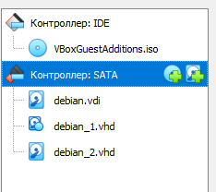

Use the lsblk command to view the status of partitions.

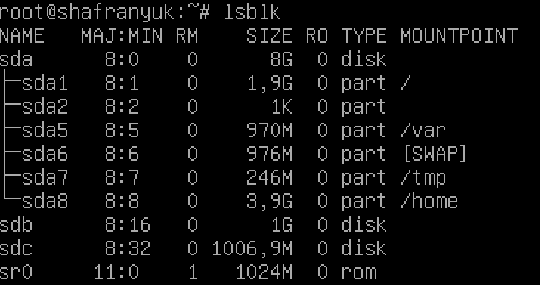

Creating RAID 1 based on sdb and sdc, for which we will initially create sdb1, sdc1 partitions using the fdisk command.

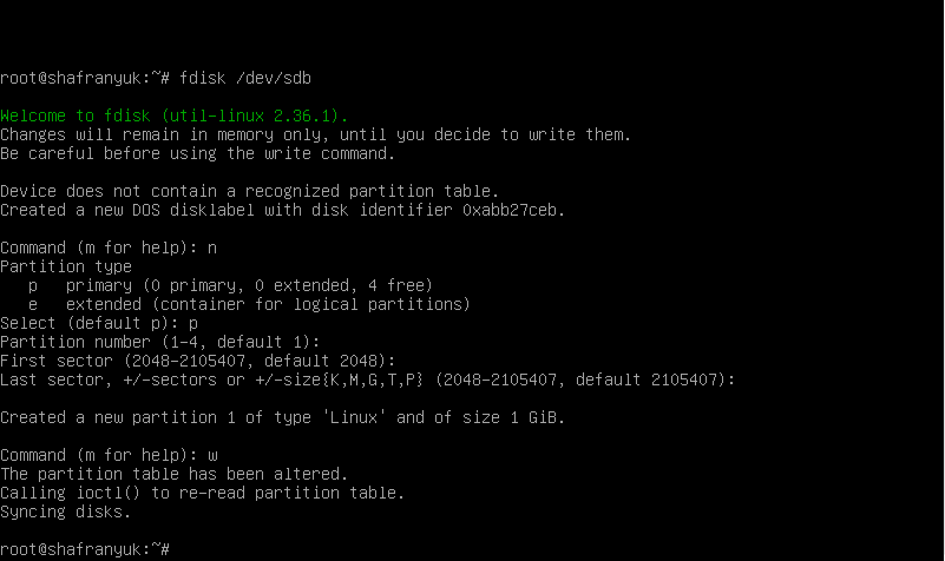

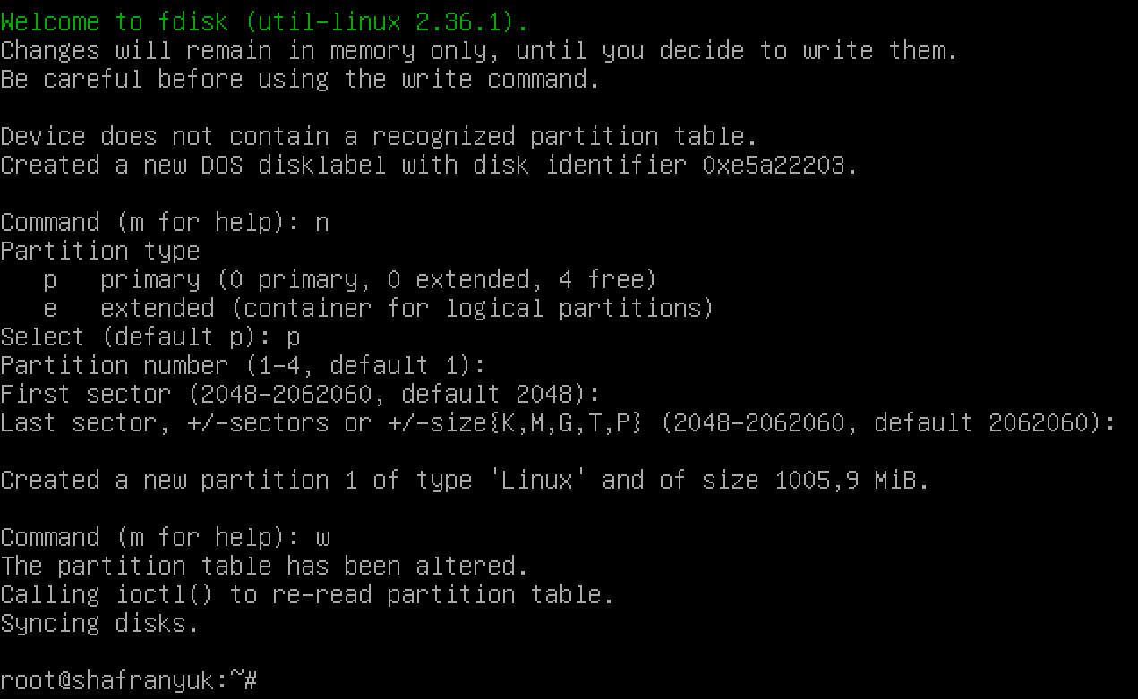

View again with the lsblk command

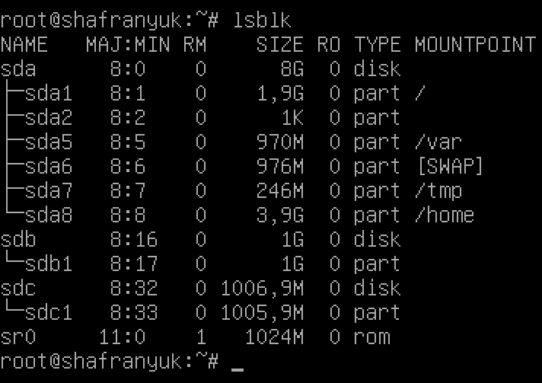

Create a RAID1 array in /dev/md0 based on the created partitions using the mdadm command:

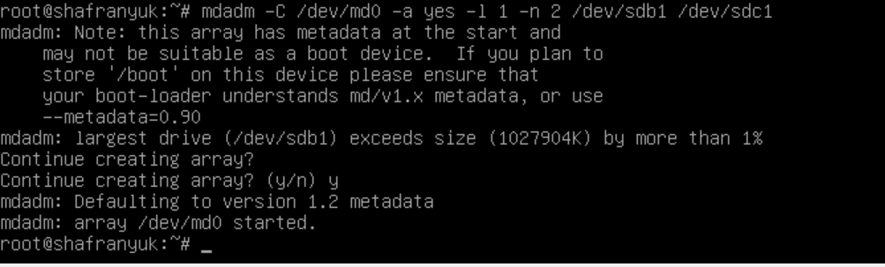

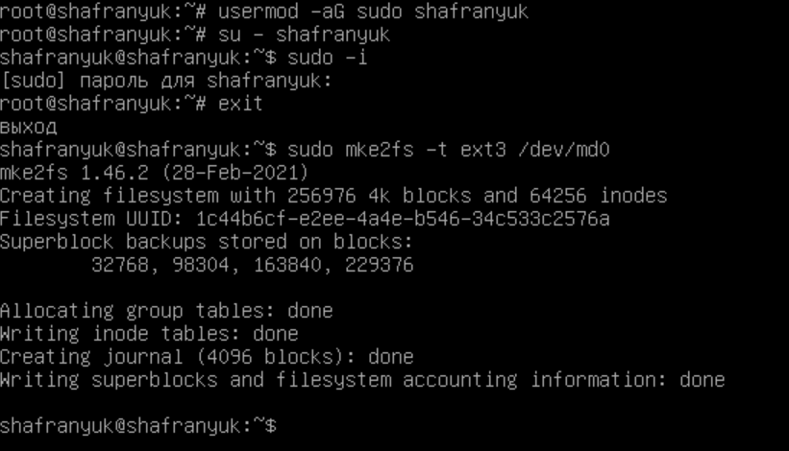

Mount the file system: sudo mount /dev/md0 /mnt

Check for success:

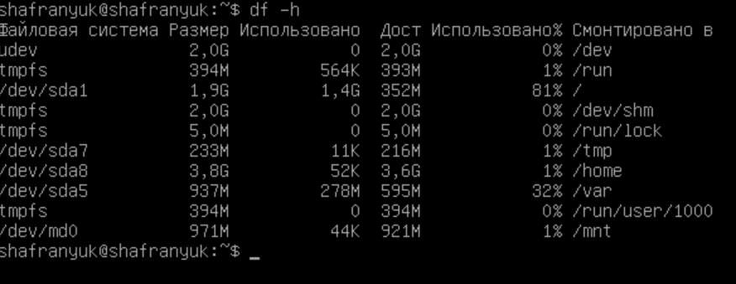

How to test raid1. Create file on raid1 file system. Turn off vm and

remove one of the hhds from vm. Turn on vm. File should be

accessible.

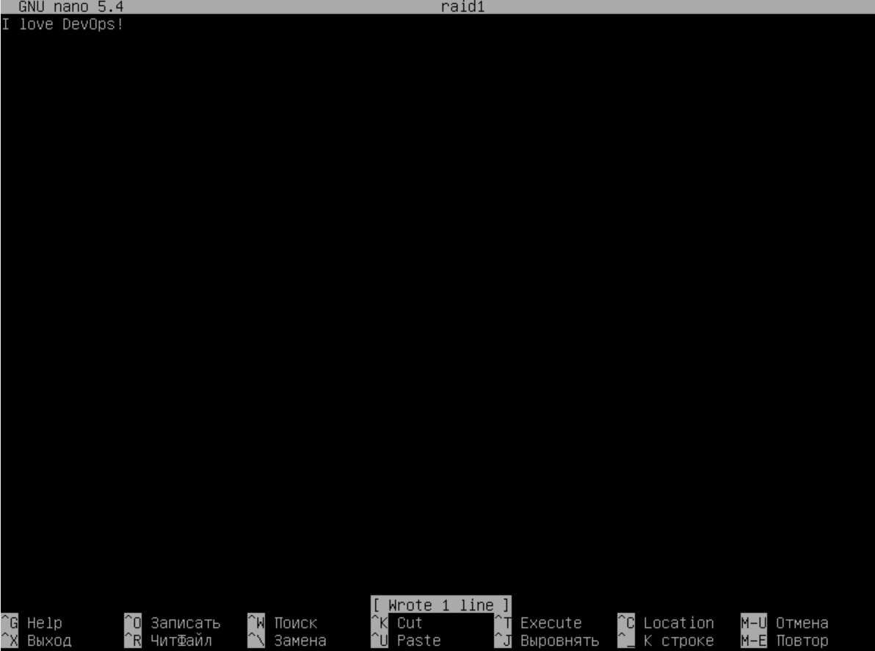

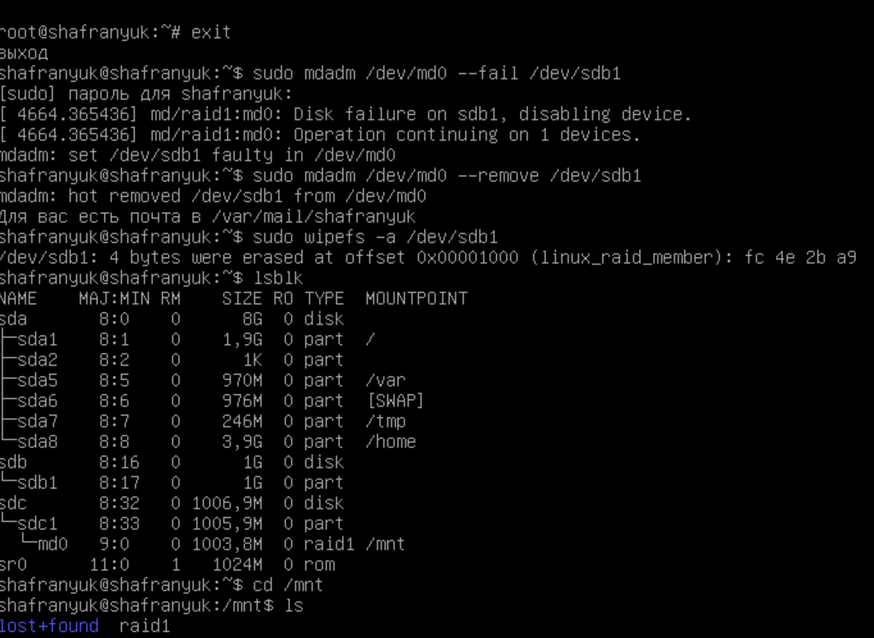

Add new hdd and sync it to raid1

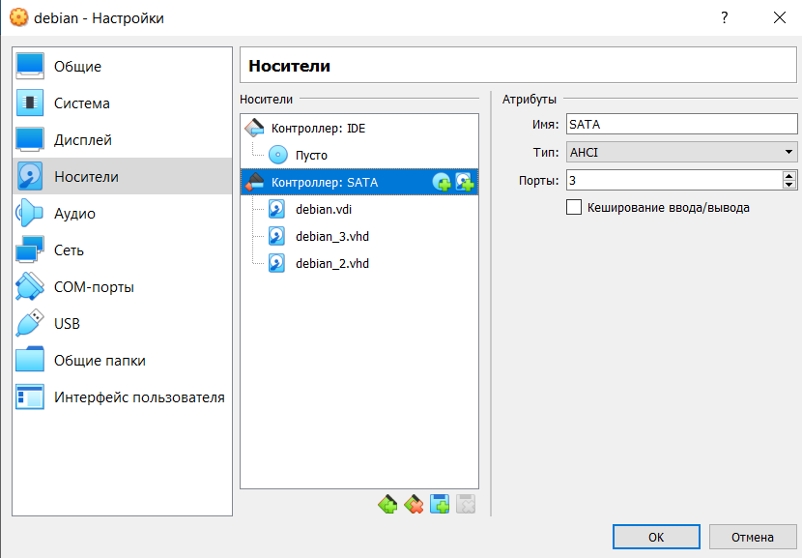

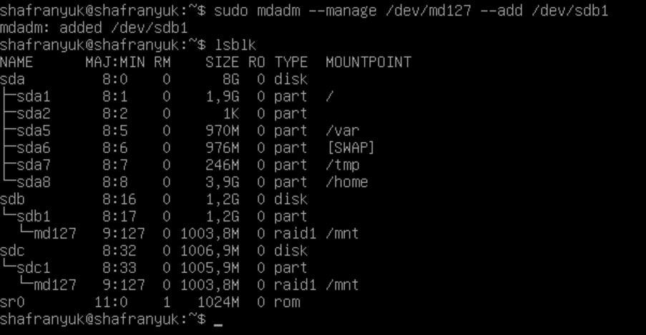

Install and run local Kubernetes cluster with **minikube**

* Use steps from `Kubernetes install Tools` https://kubernetes.io/docs/tasks/tools/

Make report with screens of:

* `minicube version` command output

* opened Dashboard in your web-browser

* web-abblication in your web-browser (http://localhost:7080/ in tutorial)

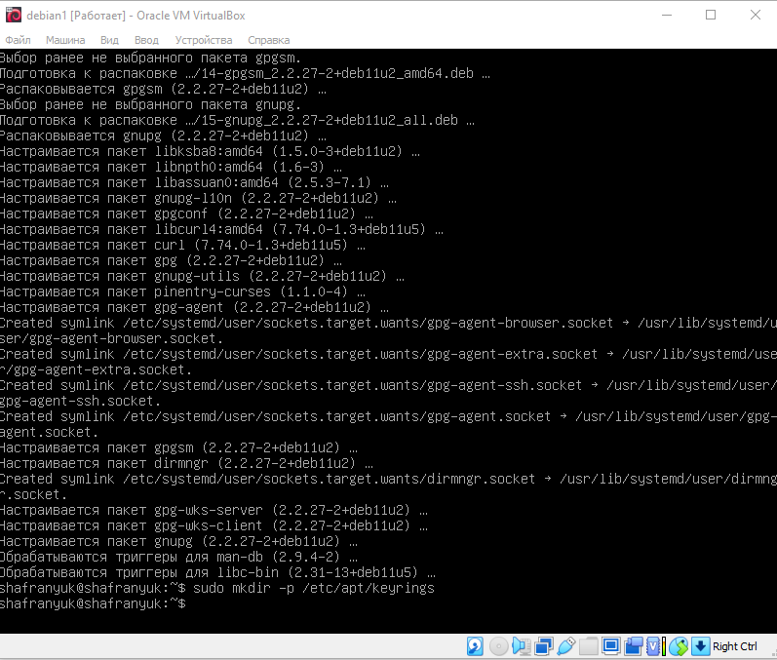

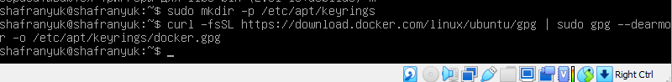

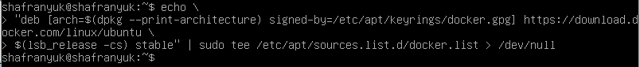

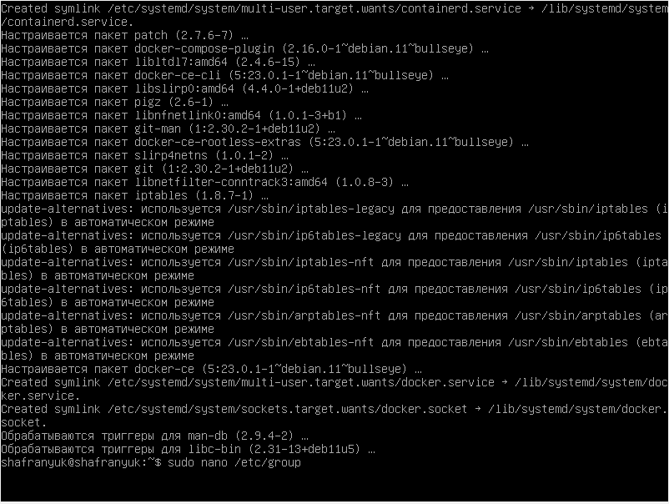



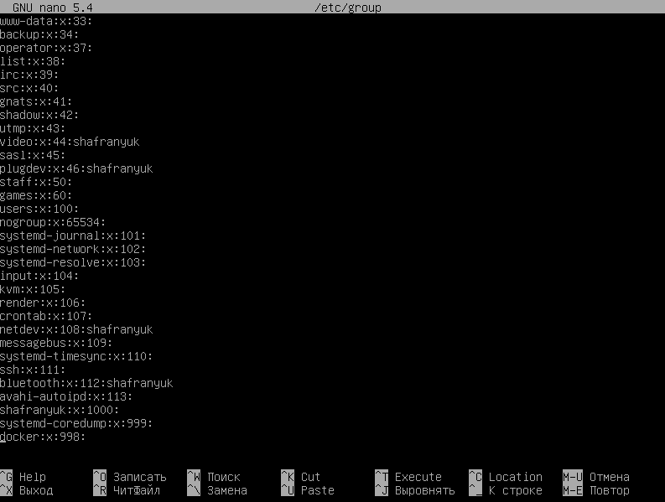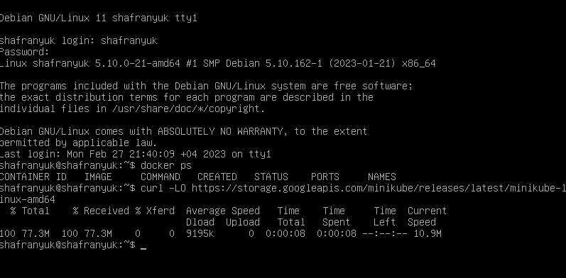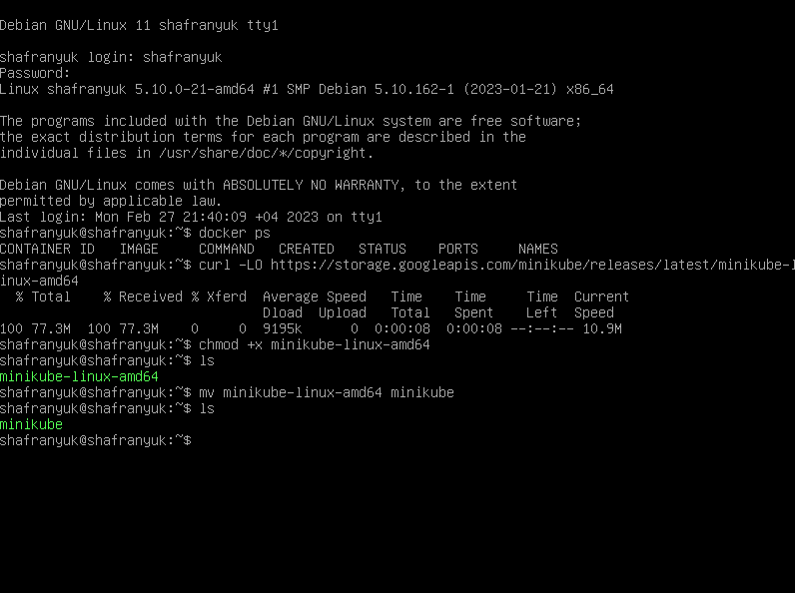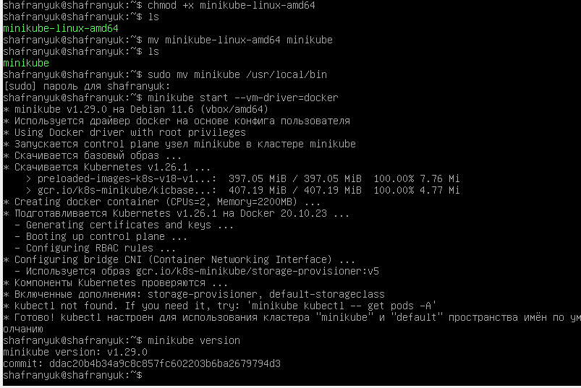

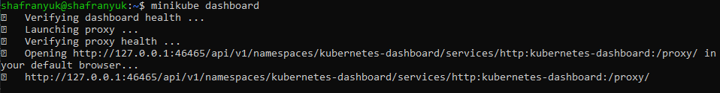

w3m http://127.0.0.1:46465/api/v1/namespaces/kubernetes-dashboard/services/http:kubernetes-dashboard:/proxy/

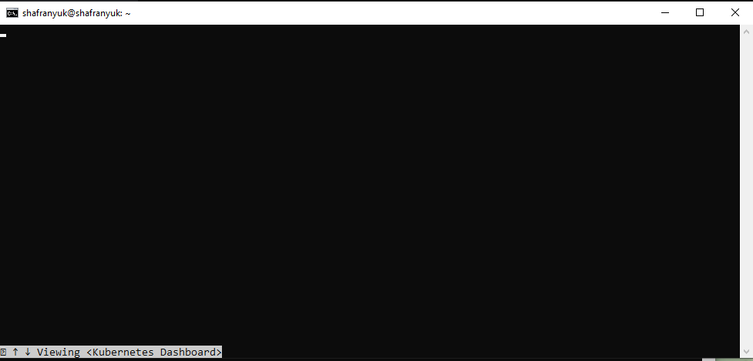

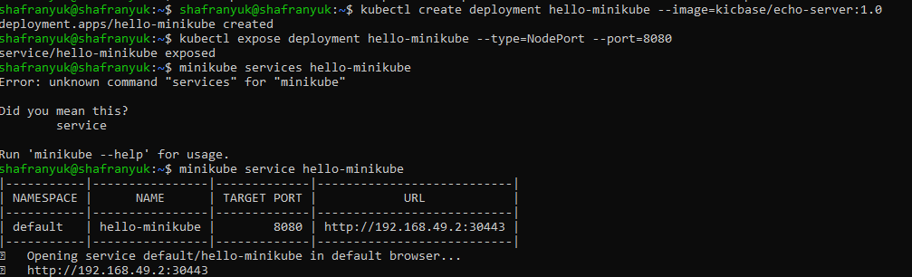

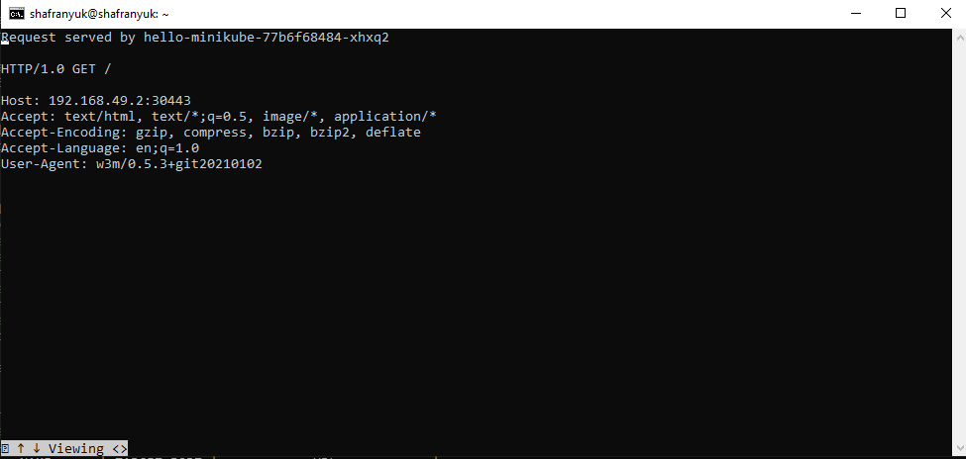

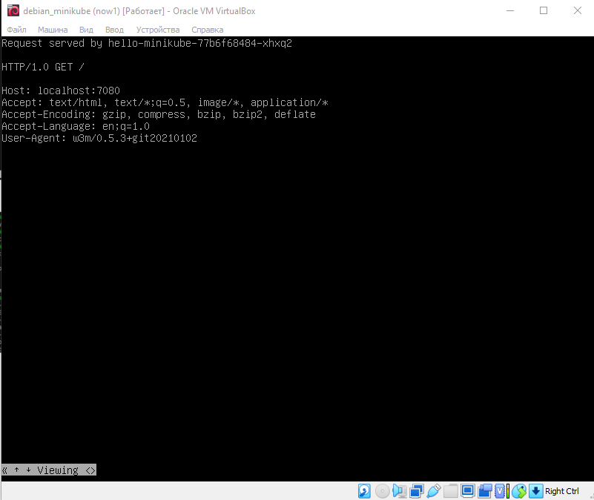

**CONCLUSION**

In the conclusion of the laboratory work, the basic utilities of the Ubuntu system studied for working with the file system, partitioning and creating RAID arrays; all steps completed successfully.

Initial skills in working with kubernetes based on the minikube training application were also obtained. With the help of minikube, a cluster was deployed locally and an application was leaked there, which could be observed on the dashboard.